CIS-40A Lab 4: Network Protocols Analyzer for Network Monitoring and Linux IP Configuration

In this exercise, we will use Wireshark to analyze network traffic and examine packets, in addition to configuring and obtaining IP information in Linux virtual machine.

Part A: Wireshark Network Protocol Analyzer for Network Monitoring.
In this lab, we will be using network protocols analyzer applications, such as Wireshark protocol analyzer, to evaluate sent packet information and their protocols in captured network traffic.
Wireshark is a network protocol analyzer, or an application that captures packets from a network connection, such as from your computer to your home office or the internet. Packet is the name given to a discrete unit of data in a typical Ethernet network. Cybersecurity professionals often use Wireshark to trace connections, view the contents of suspect network transactions and identify bursts of network traffic.
- On the classroom PC, enter “wireshark” on Windows search bar.
- Click Wireshark app to launch the application.
- Select Ethernet interface Local Area Connection and click the blue fin at the top to start the capture of network traffic.
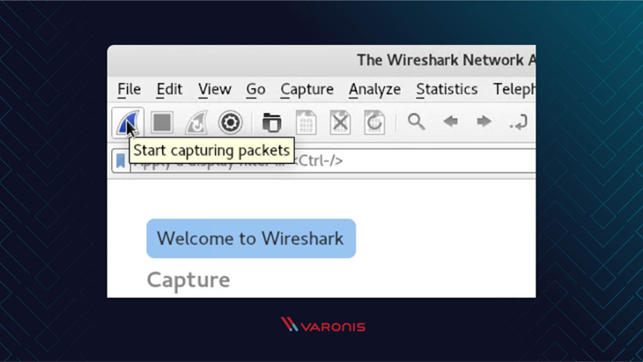
- Open the browser application, Chrome, Edge, or Firefox and visit http://info.cern.ch/ to generate HTTP (port 80) traffic.
- Wait a few minutes, then click the red Stop button at the top to stop the capture.
- Review the traffic by referring to the below table for the packet color code.
Color in Wireshark | Packet Type
Light purple | TCP
Light blue | UDP
Black | Packets with errors
Light green | HTTP traffic
Light yellow | Windows-specific traffic, including Server Message Blocks (SMB) and NetBIOS
Dark yellow | Routing
Dark gray | TCP SYN, FIN and ACK traffic
Wireshark shows you three different panes for inspecting packet data. The Packet List, the top pane, is a list of all the packets in the capture. When you click on a packet, the other two panes change to show you the details about the selected packet. You can also tell if the packet is part of a conversation.
- No.: This is the number order of the packet that got captured. The bracket indicates that this packet is part of a conversation.
- Time: This column shows you how long after you started the capture that this packet got captured. You can change this value in the Settings menu if you need something different displayed.
- Source: This is the address of the system that sent the packet.
- Destination: This is the address of the destination of that packet.
- Protocol: This is the type of packet, for example, TCP, DNS, DHCPv6, or ARP.
- Length: This column shows you the length of the packet in bytes.
- Info: This column shows you more information about the packet contents, and will vary depending on what kind of packet it is.
- Packet Details, the middle pane, shows you as much readable information about the packet as possible, depending on what kind of packet it is. You can right-click and create filters based on the highlighted text in this field.
- The bottom pane, Packet Bytes, displays the packet exactly as it got captured in hexadecimal.
- Scroll up and view the first packet. Refer to the above table.
  - What type of traffic is the first packet? UDP Packet
- Click the Protocol tab.
- Locate HTTP packet (light green). Note: This traffic was generated when completing step #4. If you don’t see HTTP traffic, repeat steps 2-5.
  - How many HTTP packets were captured? 15
- Click on a HTTP packet and view the information on the lower pane. You can click arrow next to Ethernet to expand the details view.
  - What is the source IP address? 10.151.101.12
  - What is the destination IP address? 146.75.94.172
- On the lower left pane, click Transmission Control Protocol to expand the view of information.
  - What is the source port? 54867
  - What is the destination port? 80
  - What is the TCP payload size? 361 bytes
- On the HTTP packet, click Transmission Control Protocol to close the information.
- On the lower left pane, click Hypertext Transfer Protocol to expand the view of information.
  - What is the time stamp of this packet? 9/22/25 18:54:42 PDT
  - Does the packet contain HTTP request or HTTP response? Request
- Double click on the HTTP packet and view the packet’s information.
  - What type of connection is shown in the packet? Keep-Alive
  - What is the User Agent information of the packet? Microsoft
- Close the packet information window.
- With the HTTP packet selected, click Analyze menu at the top select Follow option and click HTTP stream.
  - How many packets contain SYN? 1
  - How many packets contain ACK? 57
  - How many packets contain SYN/ACK? 1
- To clear the filter, click the red X on the right of the filter bar.
- Click Statistic on the menu bar at the top and select UDP Multicast Stream option.
- View the UDP Multicast Stream information.
  - How many UDP Multicast Streams were captured? *See small italicized print at the bottom of the window (above Burst Measurement Intervals). 13
- Click Close button to close the window.
- On Wireshark menu bar, click Statistics menu and select Endpoints.
  - How many endpoint systems are shown? 5
- Click on the TCP tab in the Endpoints window.
  - How many TCP packets were transmitted? 177
- Click the Port tab in to sort the list of the ports used for TCP packets by the endpoint systems.
  - How many packets used port 80? 126
- Close the Endpoint window.
- On the Wireshark menu bar, click Statistics and select the I/O graph option.
  - Take a screen capture for lab submission.
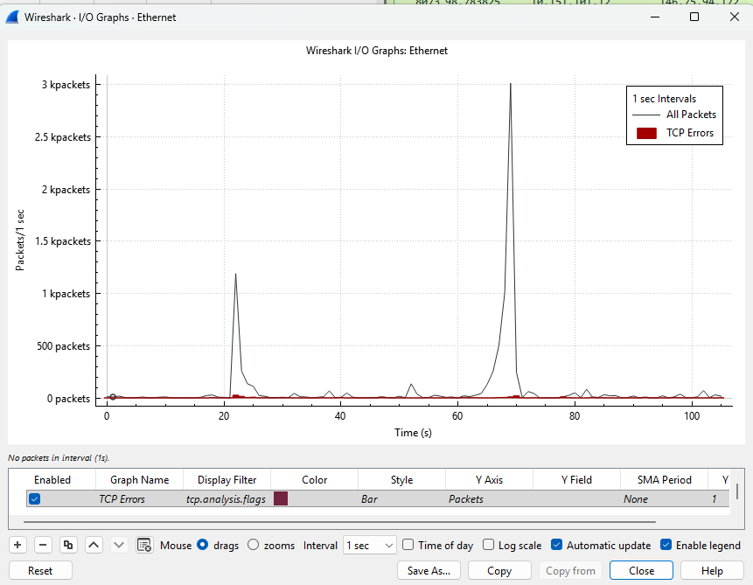
- Click Close button to close the graph.
- On Wireshark menu bar, click Statistics, then click Conversation.
- Click UDP tab in the Conversation window.
- Click Port B to sort the port list of UDP in the Conversation window.
  - What ports are listed under Port B? 53, 137, 547, 1900, 5353,5355,
  - Is port 53 being used in UDP traffic? yes
- On Wireshark menu bar, click Statistics, then select IPv4 Statistics IP Protocol Types.
  - What is the count for IP Protocol Types? 8128
  - What is the percentage of TCP traffic? 98.33
  - What is the percentage of UDP traffic? 1.67
- Close the IP Protocol Types window.
- On Wireshark menu bar, click Statistics, then select DNS.
  - What is the total packet count for DNS? 107
  - How many DNS queries and responses were generated? 54 Queries and 53 Responses
- Close Wireshark app and select Quit without Saving button.

Part B: IP Configuration Linux – Not required – Will do this lab in the later weeks.
- Visit https://www.kali.org/get-kali/#kali-virtual-machines
- Click the Download link for VirtualBox. DO NOT DOWNLOAD WEEKLY KALI VM!
If you are using Edge browser, click Save As and browse to Downloads folder, then click Save. This is where your zipped Kali VM will be.
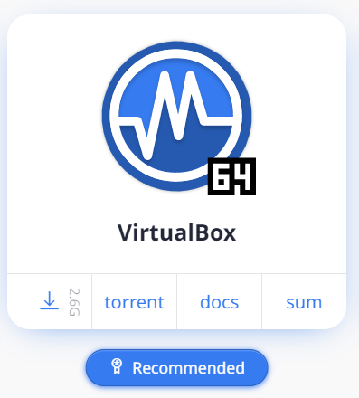
- When download is completed, open File Explorer Downloads.
- Right-click the downloaded zipped file: kali-linux-2024.2-virtualbox-amd64.7z, then select Show More Options, then select 7Zip Extract Files OK.
*If 7Zip is not installed, visit https://www.7-zip.org/download.html to download and install applications.
- Once decompression is completed, return to Download folder, open the decompressed folder kali-linux-2024.2-virtualbox-amd64 and its subfolder.
- Double-click the file with the BLUE icon, kali-linux-2024.2-virtualbox-amd64.vbox.
*If VirtualBox app is not installed on the system, visit https://www.virtualbox.org/wiki/Downloads to download and install VirtualBox to play the virtual machine. Your system must have sufficient RAM (at least 8GB), drive space and quad-core processor to play the virtual machine.
- Click Start button (green arrow) in VirtualBox app.
- Once Kali VM is loaded, login:
  - Username: kali
  - Password: kali
- Click the Terminal icon (black square) icon at the top.
- To find the system IP address using Terminal, input the command and press Enter key:
ip address
  - What is the inet address for loopback? * 127.0.0.1/8
  - What is the inet address of the ethernet interface? 10.0.2.15/24
  - Take a screen capture for lab submission. 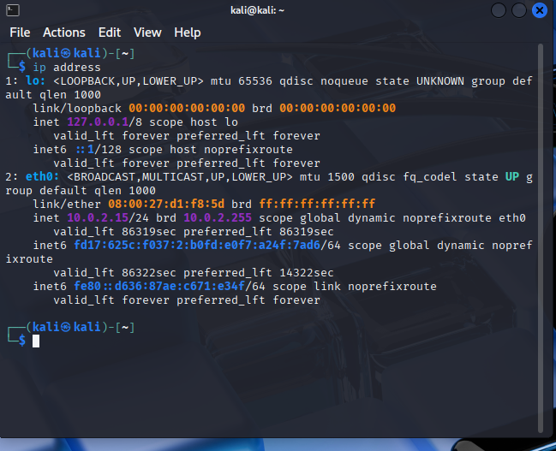

- Click on the Application (dragon button at the top left) and click Settings.
- Click Advanced Network Configuration.
- Under Ethernet, click Wired connection 1 and click the setting button (wheel at the bottom of the window)
- Click on IPv4 Settings tab and click the Method drop-down menu and select Manual
- Click Add button and enter the IP (inet) address: 172.168.12.X-replace X with value from 100 – 250
Example: 172.168.12.125
- Click on the subnet mask field and enter the Netmask: 255.255.0.0
  - How many bits are used for network ID in the subnet mask? 16
  - Which IPv4 address class is used? Class B

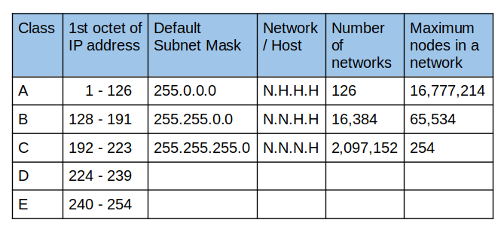
- Enter the Gateway Address: 172.168.12.1
  - Take a screen capture for lab submission. 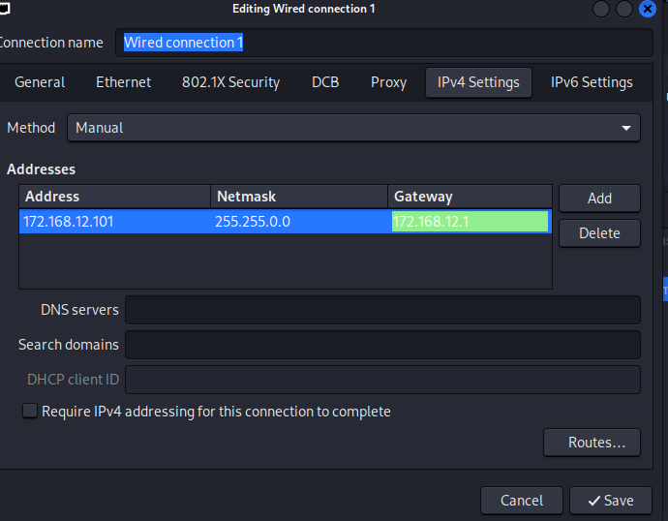

- . Then click Save. Then, close the Network Connections window.
- Return to the Terminal and reboot the virtual machine using command: reboot
- Login:
Username: kali
Password: kali
- Open Terminal (click black square icon) and use ip address command to locate the updated IP address.
  - Do you see the added inet/ip address from step #48? yes
  - Take a screen capture. 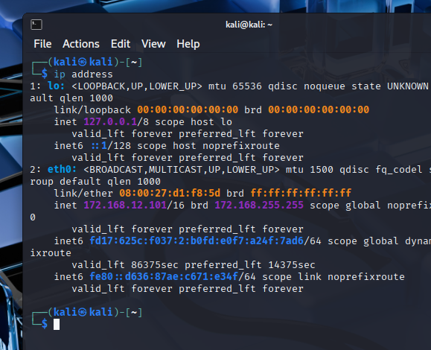
- In Terminal, we will temporarily change the IP address:
sudo ip addr add 12.0.0.X/8 dev eth0
Replace X with value between 100-254.
- Enter password: kali
- In Terminal, reboot using command: reboot
- Then login and open Terminal use command ip address to check eth0 interface to verify the change from the previous step.
  - Does the system show the IP address that you have added in step #55? I see it on the list, but along with the original
  - Take a screen capture for lab submission. 

Note: To input static IP address in Linux, we must use text editor (nano) to modify the configuration file.
sudo nano /etc/network/interfaces
auto eth0
iface eth0 inet static
address 12.0.0.102
netmask 255.0.0.0
gateway 12.0.0.1
dns-nameservers 12.0.0.12 12.0.0.14

- Next, we will show the configuration with the updated address in Terminal:
sudo ip address show dev eth0
- Enter password: kali
  - Take a screenshot for lab submission. 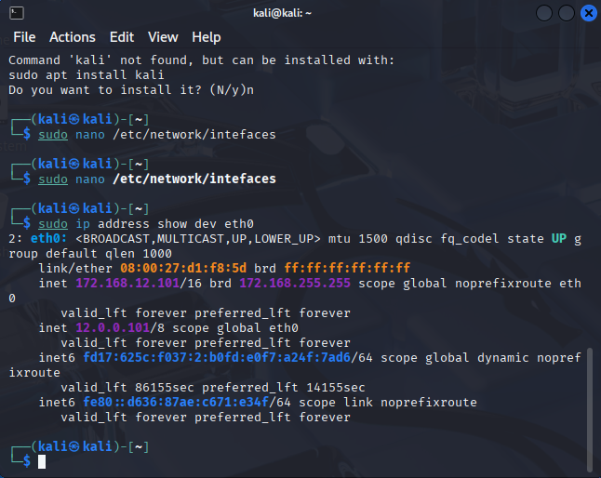
  - What is the interface state? Up
- In Terminal, shutdown the virtual machine using command: shutdown now
- Close VirtualBox.
- Answer the following questions:
  - Upon completion of this lab, what did you learn about Wireshark and IP configuration on Kali Linux? I leaned how to use Wireshark to analyze packet info as well as how to configure the IP address in Linux
  - How can you apply learned concepts to your IT or cybersecurity career? More and more of networks are using various Linux Distros as the backbone of their networks, and being able to use Linux effective is almost required at this point. As a Cybersecurity Analyst, being able to get the required info out of packets can help ensure the safety of the system
- Save your screen captures, questions and answers on a lab document that contains lab screen for Canvas submission.
- Login Canvas and submit the document containing lab questions, answers, and screenshots.
- Remove USB drive and shutdown the classroom PC.

